2017 Dance Flurry – Dance Organizers Discussion Group
Lead by/notes from: Emily Addison (EmilyLAddison@gmail.com)

IDENTIFYING CHALLENGES/TOPICS OF INTEREST
After introductions, Emily briefly explained the poster boards around the room which listed common challenges/topics of interest to organizers. (These topics had been identified through prior work such as last year's organizers session at the flurry and CDSS's 2016 Canadian organizers survey.) Session participants were asked to choose their top three issues and place different coloured stickies to identify their priorities # 1,2,3 on poster boards around the room. They also had the choice of writing down other topics if their pressing issues were not already listed.

Here's an example of the sticky note boards:
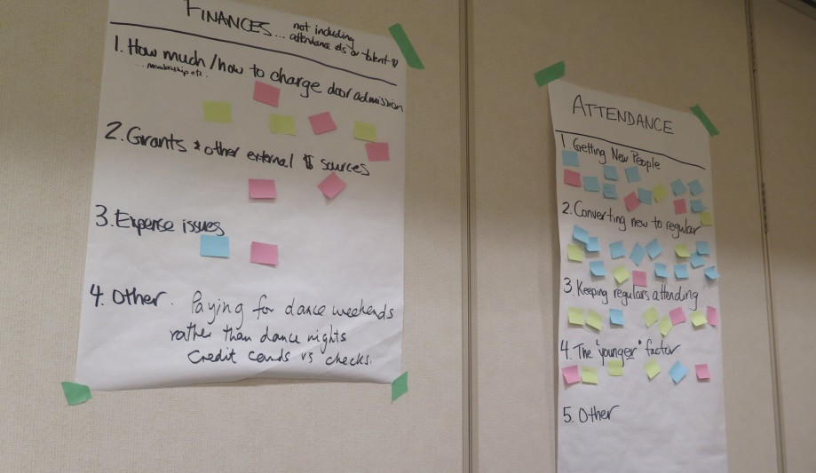

Here's a graph showing the relative interest in various topics:

Other topics written down by participants:
- Paying for dance weekends – credit cards vs cheques
- Skill building among 'experienced' dancers
- General consent building
BRAINSTORMING ON TOPICS OF COMMON INTEREST

Getting new people in the door:
- Mary @ Buffalo: Used to do the following and considering reinstating – if a member is in good standing, you get in free if you bring a new person with you (actually has to be with you). The new dancer gets a second dance free card. Sounds like BIDA does this too. This encourages more membership as if someone is consistently bringing new people, it's an incentive for them to become a member as they will get in free.
- Alex @ CDNY: For their English series, they have a few dances a year where it's 'bring a friend' (new dancer)… both the new dancer and the experienced friend get in free. The new person still gets 2nd dance free pass. Keeps balance of regulars and newbies. Pick the nights based upon great talent.
- Ed @ Ottawa: Held a competition to see who could bring in the highest number of new people over the season. Free season's pass was the top prize. This didn't work so well, may to tweak.
- Is the best way to get new people through your regular dancers? Hands up …. about half of the room agrees.
- ???: Free dance at the college which brings folks. They come for four years and then leave.
- Cross pollination:
  - ???@ Rochester: Stay connected with other dance organizers in the city. Tie into those other dance populations.
  - Rockabilly @ Rochester: A good amount of cross-pollination. For rockabilly, his best source of dancers has been contra.
  - ???: Caution is that really need to communicate so that they don't offer dances on the same nights. Even coordinating Buffalo, Rochester, Toronto contras.
- Alex @CDNY: Lots of success cross-promoting with groups like International students, Jane Austin Society.
- ??? in NYC: Beyond cross-pollination, co-host events with other dance groups.
- Keith @ Rochester Rockabilly: Another local dance group has a college night. Get in free if show a college or high school ID.
- Dave @ Jonesborough: Formal press release for every event to all print media and radio stations. Take station manager to lunch and build relationships with them and they become your advocate. Have never paid.

Converting new to regular:
- Bob @ Rochester: Always offer beginner lesson.
- Multiple groups use 2nd dance free cards:
  - It's a no loose strategy - if come back second time, likely to come back more and they are likely bring someone with them.
  - Buffalo: Date the back of the cards as a tracking mechanism for data purposes. Others also do.
  - Donna @ re another series: Collect then new dancer info and add to mailing list. Others also do.
  - Alex @ CDNY: They get new people's emails the first time they come as their 2nd dance free cards have two portions. One part the dancer takes and the other they leave their email for follow up, including where heard from.
- Personalized invite to come back after the first dance… multiple groups doing this.
  - Alex @CDNY: After each dance, send a personalized email to each new dancer… 'welcome, so nice to see you on dance floor, dates of next two dances, come back'.
  - Mary @Rochester: Get their email through a sign in book. Encourage that over the mic. Within the week, send a welcome email. Instead of sending from mail chimp, send from personal email address so more personal and not go to spam folder. Include big welcome, how did you enjoy, encourage contact if have any concerns as do have a few of 'those issues'... anything happen that made feel uncomfortable, please let me know… how can we help you come back.
- Dave @ Jonesborough: If new dancers don't feel part of your community within first 3hrs, 10% chance they'll come back.
- Dave @ Jonesborough: They do a whole program of welcoming, data mining, skills assessment … coddle them. For example:
  - Board members stand at the doorway. Greet them, welcome to the dance, do a skills assessment, take by hand and partner them up with experienced dancers for the first few dances.
  - Data mining (??? details)
  - Try to send welcome email – welcome to our dance community, what your experience like, what like/not like, would you tell your friends about it, would you come back?
  - Take a lot of pictures and post on facebook. Great re tagging friends and friends of friends see them… looks like fun.
  - ???: Suggestion from another organizer that hesitant to post photos on facebook without a system where people can opt out as not all people comfortable with their photo online.
- Donna @ Philli: – recommends generation/generation connection. So if young person in the door, make sure young person approaching and welcoming them and introduce to their friends so they've got peers.
- ???: Notice who is new during the beginner lesson and have board members and others dance with them. Also help them find partners.
- ???: As dancing, notice who is new and sitting out and approach them for the next dance. Then introduce them to other dancers.
- ??? @ a blues dance: Taxi dancer (bandana or flower to ID) which means 'dance with me if you're new'… safe person to ask to dance, willing to provide pointers if want. Selected set of six people that do this role. 1-2 do it each dance, identify them after the lesson. Seems to work well.
- ??? @ Montpelier contra exchange: Self-selected 'dance ambassadors'. Magnetic flower pins at the front desk to ID – that way know who has them. The organizers also go around and ask people who they know are good.
- ??? @ Montpelier contra exchange: after the 2 or 3rd dance, do a skit with a couple of people in the centre, showing how to ask to dance, here's how you can say no, trying to model that community behaviour.
- Alex @ CDNY: Diner after the dance – she will go around at the break and welcome folks and encourage them to go, love to see you. So they know they're welcome to join in. Also, she will introduce them to people if they aren't talking to folks at the break.

More skilled/able leadership & organizers
- Issues: Aging and tiring out; local dance is 'my job'; and also new group with not enough.
- ???: Committee brought her on a whole year before they needed her to take on tasks. She got to observe and learn.
- Ed @ Ottawa: Joined the local board as a members at large – essentially, their role is to help with special projects as needed. From there, could take on larger roles within the board.
- Ed @ Ottawa: Volunteering builds community.
- Donna @ Philli: In addition to announcing from the mic, personally talk to the people. Even if a small job like water jugs to get them started. Then see who takes to that and invite them to join the board.
- Emily @ Ottawa: The personal invite in volunteer management is key. Especially for larger jobs.
- Emily @ Ottawa: Look around and ID those dancers who look like they want that extra 'community/belonging' bit as a board member role will likely be more appealing to them.
- Catherine @ Yale Infusion: Board of 7 people. Each semester they have classes/dances/workshops and they have a large meeting. Anyone who has organized in the past or has been showing up are invited to that meeting. 25 people last time. At the meeting, they ask for point people to take on certain tasks for next 6 months. If someone interested but doesn't know how, someone helps them learn. If attend that meeting, you are invited to the Slack channel (e.g., channel for workshops; channel for community culture) and can participate in the ongoing discussion.
- Bob @ Rochester: Election for board. Have people out recruiting for the board. By-laws backfired as had term limits of 5yrs. The jobs became viewed as a 5yr commitment which was quite problematic.
- Alex @ CDNY: Often boards feel impenetrable. At YDW, youth talked about wanting to organize but that it's hard to break into organizing committees that have been going for a long time. Think of ways to bring in new people and be ok with new and different ideas that they may bring.
- ???: There's also the issue of 'not being able to let go' even if saying they can't find someone to replace them.

How much/how to charge at the door, membership…:
- Linda @ Lennox contra: Their attendance was dwindling as was their surplus. Thus, last year they started 'sustainers' which is like membership. Dancers paid a full year in advance which gave a stable amount of money every month. Simply check people off as come in. Weren't going to continue it this year as didn't need it but dancers liked it and wanted it to continue. They got a discount – regular charge is $12/$6 for students. $125 for 12 dances.
- Ed @ Ottawa: We also have seasons pass where pay for whole year ahead. But separate have membership with different benefits and sustaining membership where people can donate a bit more to 'the cause'.
- Robert @ Rochester: Do similar (seasons pass) but need to check people off for year-paid at the door in order to figure out talent pay for the night.
- ???: Had to change fees. Inundated by middle-schoolers which meant income dropping. Lots of energy, low skill. Fewer and fewer adults. Raised rate for kids to pay performers.
- ??? Montpelier exchange: Their door is sliding scale $6-12 and they routinely bring in more per dancer and make more per dance than the fixed fee CDU contra dances at the same hall. They have a sign right out front 'This is a sliding scale dance... this is how much it costs us to put on the dance… if everyone paid $10 we need 120 dancers to pay…' So very up front about what it costs and what their contribution means to the band, caller and sound people.

Not enough talent/how to develop it:
- Bob @ Rochester: Monthly callers workshop. Go to a house. Sometimes live music, most times recorded. Call dance and get critical feedback. Then he, as the booker, asks the caller, often local, to give one dance to the beginning caller. Have the dance ahead of time. If say no, back off. Next is mentor where get half a dance. Then he would book for an evening.
- Bob @ Rochester: Started open band 5th Thursday of the month. Backbone of experienced players. They have a set sheet and chords for people. People can get up on stage, not mic'd. Everyone knows what to expect.
- Boston contra does that.
- Donna @ Philli: Been doing this for years. Will have 30 musicians and 60 dancers. Lots of bands have spun off of that. Planted musicians with mics and then others can play along behind them.
- ??? @ CDNY: Have open bands for English and contra. They(organizers?) get the 'free performance'. They find that musicians bring friends and family so more people there. Do pay for coaches to help the band and they rehearse a few times a year. Still profit off them. For English, have apprenticeship program with individual coaching, guests slots and graduate into regular rotation.

Dance floor/community culture:
- ??? @ swing/blues: Model this at our workshops - asking to dance, asking which role would like to dance. And setting up clearly point people if have concern (announcements). Including at the door as people walking in.
- ??? : Small enough contra dance that the 3-4 core organizers will take people aside if see what they think are dangerous behaviour – things like too rough or spinning too quickly. Will address it as soon as the particular dance is over. Unfortunately not always met favourably. Sometimes tag team where a second person will say the same message.
- ???: At the Flurry they have dance culture guidelines in the bathroom. Want them!
- ???: We put similar message up in our washrooms … welcome, glad here, if experiencing any issues with particular dancers please see someone on our committee. So we feel everyone will see that as almost everyone has to go to the bathroom. Feel that has helped. We used to have issues for a while but not the last few years.
- ???: Make sure your organizers have talked about this issue and how you will respond and what your answer will be. Otherwise, you can be ambivalent and dancers get caught in the middle.
- ???: As you welcome the new people, introduce them to other dancers etc., that is making them comfortable to express to you, the welcomer, if someone made them feel uncomfortable.
- Lindy hop in Rochester: In wake of Steven Mitchell scandal a few years ago, they have an annual town meeting where all welcome, night free, sit in circle, talk about issues of safe space. There is a professional counselor who member of team and give out her information. If concerns about inappropriate or predatory behaviour etc. on the dance floor, can contact her and she will bring to the Groove Juice board.

Other/last minute items:
- Montpelier exchange: First half is contra and the second half is something else (swing; Cajun; etc.)… exchanging dances and bringing new skills into the community.

