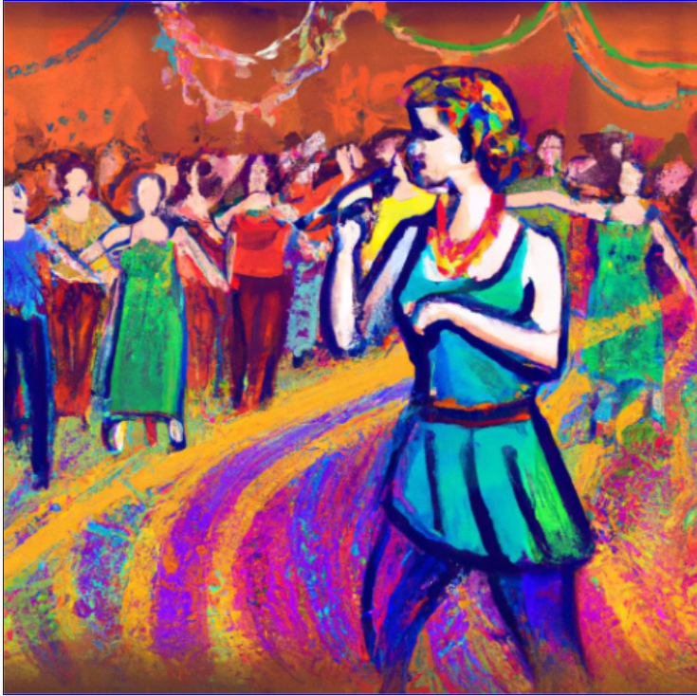
Contra Dance &
Positional Calling Workshop

April 28 and 29, 2023
Atlanta, Georgia

April 28 | Friday Dance and Potluck Discussion @ Decatur Rec Center
- 6:00 - 7:45 Potluck and community discussion on gender neutral calling and role terms
- 7:30 - 8:00 Beginner Lesson
- 8:00 - 10:30 Dance, positional calling by Beadle and tunes by Snapfinger with Ed Howe
-- Leila Soulen (fiddle), Alan Gordon (mandolin, cittern), Laura Joseph (guitar)
Russ Sites (guitar, clawhammer banjo), and Ed Howe (fiddle)

Since the middle of 2022 the Atlanta dance community has been experimenting with a gender-neutral calling style called Larks and Robins. Our goal is to build a more inclusive dance environment and emphasize how anyone can dance any role, with anyone. We’d like to invite you to a potluck before the Friday dance to come and talk with us about how it’s been going and hear community thoughts.

After the potluck, our Friday dance at Dec Rec will intentionally introduce a third option for gender neutral calling - positional calling, which removes gender and role terms altogether. Our intention is for these experiments to explore ways to deliver great dances efficiently, inclusively, and authentically. Come check it out and give us your feedback!

April 29 | Saturday Caller Workshop: ‘Positional Calling’
10:00 - 12:00 – Near Decatur, GA
Sign up for the workshop here
- Facilitated by Beadle. He has been dancing for 10 years, calling for 7 years, and doing positional calling for 4 years. He loves dancing anywhere on the dance floor and with whoever is coming at him! Ed will play fiddle, he is a longtime contra dance musician who enjoys rhythms that push the envelope while honoring traditional music.

- Come to the Friday night dance to experience Positional Calling, then come Saturday morning to try to call one yourself! This workshop is designed for all levels of callers– from experienced callers to help innovate their repertoire and try something new, to new callers who want to play with an additional way of calling to find a groove that works for them and their dance communities.
.
- Bring a dance you’d like to learn how to call in the positional style. We will work together with Beadle to rewrite the dance with positional references and remove any gender/role terms. For more info on positional calling: video and website. Email dahltami888@gmail.com with questions.
Organized by the Chattahoochee Contra Dancers

